
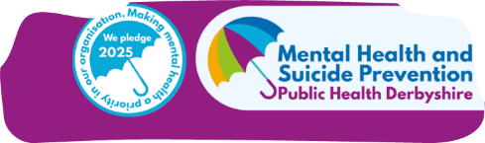

Derbyshire Dales Children & Young People
Emotional Wellbeing Small Grants Programme (Up to £5,000)
This guidance supports organisations applying for funding to deliver community-based projects that improve the emotional wellbeing of children and young people (CYP) living in the Derbyshire Dales. We are practically interested in applications between £2000- £3000

1. Introduction
The Emotional Wellbeing Small Grants Programme aims to invest in local, preventative activity that helps children and young people feel:
- Confident and resilient
- Connected to peers and trusted adults
- Safe, included and supported in their community
Funding is intended for one-off or start-up projects, not ongoing delivery or core organisational costs.

2. Purpose of the Fund
Funding is available for projects that improve emotional wellbeing by providing children and young people with opportunities to:
- Take part in positive, pro-social activities
- Build confidence, resilience and self-esteem
- Form supportive relationships with peers and trusted adults
- Access safe, inclusive community spaces
- Learn new skills or develop interests
- Overcome barriers to participation (e.g. cost, transport, access needs)
Projects should:
- Address a local need or gap in provision
- Avoid duplication of existing funded services
- Prioritise rural communities and groups with limited access to support
- Reflect the THRIVE Framework, with a strong focus on prevention and early help
Definition: Pro-social Activity
For this programme, a pro-social activity is defined as an activity designed to improve wellbeing through positive interaction with others. This may include physical activity, creative or cultural activities, volunteering, outdoor learning, peer support or community-based group activities.

3. Who Can Apply
Applications are welcome from organisations that meet all of the following criteria.
Eligible Organisations
- Local voluntary or community groups with a governing document (e.g. constitution, memorandum and articles, or written rules)
- Registered charities (including CIOs, trusts, unincorporated associations, and not-for-profit companies limited by guarantee)
- Community Interest Companies (CICs) or social enterprises that:
  - Are limited by guarantee (not by shares)
  - Have a clear community purpose and charitable aims
  - Can demonstrate an effective asset lock
Governance Requirements
Organisations must:
- Have a management committee or board of at least three unrelated members
- Hold a bank account in the organisation’s name with at least two unrelated signatories
Additional requirements for CICs:
- A minimum of three Directors, the majority of whom are unpaid
- Any paid Director salaries are approved by non-executive Directors and are proportionate
- No Persons with Significant Control

4. Eligibility and Delivery Requirements
Applicants must be able to demonstrate that they will:
- Deliver activities within the Derbyshire Dales
- Deliver outside the school setting and outside the school day
- Support children and young people aged 0–18 (or up to 25 with additional needs)
- Focus on emotional wellbeing rather than clinical or therapeutic intervention
- Have appropriate policies in place, including:
  - Safeguarding
  - Health and safety
  - Data protection
- Ensure staff and volunteers have DBS checks where required
- Hold appropriate insurance for all activities

5. What We Can Fund
Examples of Eligible Activity
- Group sessions, clubs or workshops (e.g. creative, physical, outdoor, wellbeing or cultural)
- Safe social spaces and peer support groups
- Volunteering, mentoring and youth leadership opportunities
- Projects that develop confidence, connection or life skills
- Targeted activity for children and young people experiencing inequality or disadvantage
Eligible Costs
Funding may be used for:
- Venue or room hire
- Staff or volunteer delivery costs
- Equipment and materials
- Resources and training
- Transport to support participation
- One-off project start-up costs

6. What We Cannot Fund
The fund cannot support:
- Core organisational or ongoing running costs
- School-based or curriculum-linked activity
- Clinical, therapeutic or NHS-commissioned services
- Activity delivered outside the Derbyshire Dales
- Provision delivered during the school day or on school premises
- Duplication of existing, funded provision
- Large capital purchases

7. Application Process
Applicants must complete the short application form, providing details of the project proposal, budget and policies.
Your Application Should Include
- Applicant and Project Details
- Eligibility Confirmation
- Project Summary – aims, beneficiaries, location, delivery period and any partners
- THRIVE Alignment – how the project supports prevention and early help and complements existing provision
- Outputs, Outcomes and Measurement – what will change and how impact will be measured
- Partnership Working – details of any organisations involved
- Budget – a clear, proportionate breakdown of costs
- Monitoring and Reporting – confirmation that quarterly updates, case studies and a final report can be provided

8. Assessment Criteria
Applications will be assessed against the following criteria:
- Clear benefit to children and young people’s emotional wellbeing
- Evidence of local need or unmet demand
- Commitment to inclusion and reducing barriers
- Safeguarding and risk management arrangements
- Value for money
- Robust outcome measurement and reporting
- Alignment with THRIVE principles and local priorities

9. Tips for a Strong Application
- Be clear, focused and realistic
- Use local evidence where possible
- Demonstrate partnership working
- Avoid replicating statutory services
- Set achievable and measurable outcomes
- Build evaluation into the project from the outset

10. Monitoring, Reporting and Acknowledgements
Funded projects may be asked to provide:
- Quarterly monitoring updates, including activity and spend
- Information on the number of children and young people supported
- Case studies demonstrating positive change
- A final end-of-project report
All funded activity must acknowledge Derbyshire County Council Public Health funding. Approved logos and wording will be provided.

11. THRIVE Framework – Summary
The THRIVE Framework is a national approach to Children and Young People’s mental health that focuses on needs rather than diagnosis, and on providing the right help at the right time.
The Five THRIVE Areas
- Thriving – promoting wellbeing, confidence and resilience
- Getting Advice – accessible information and guidance
- Getting Help – short-term, goal-focused support
- Getting More Help – specialist support (not to be duplicated)
- Getting Risk Support – support where traditional approaches are not effective
Key Principles
- Needs-led and preventative
- Shared decision-making with children and young people
- Strong partnership working
- Clear outcomes and impact measurement
In summary, THRIVE is about helping children and young people stay well, access early support in their communities, and have a voice in the help they receive.
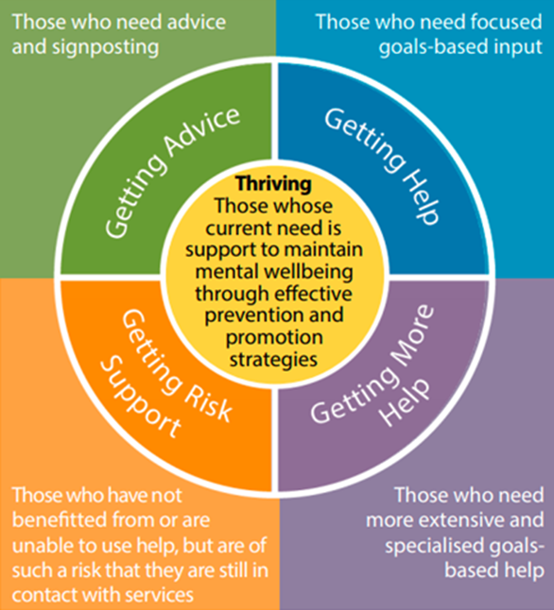
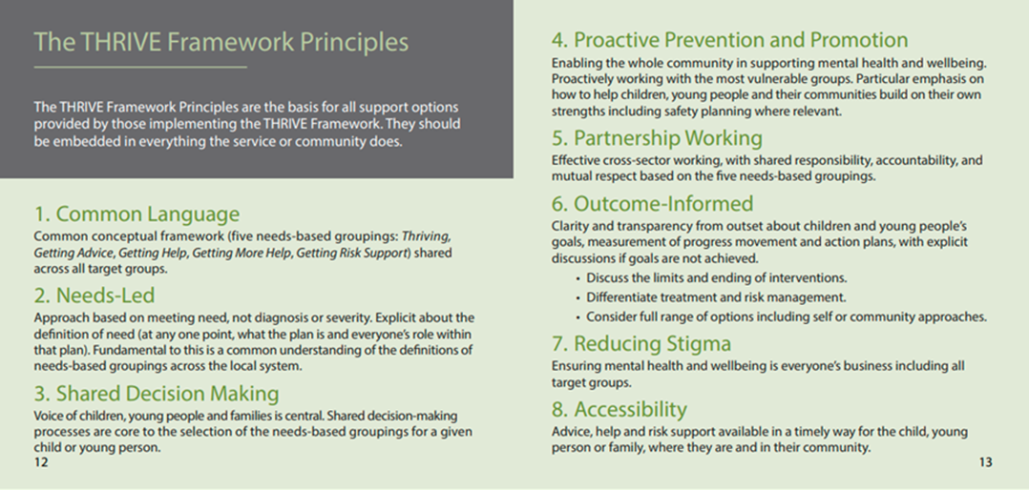

Further information:
- https://implementingthrive.org/about-us/i-thrive-principles/
- https://implementingthrive.org/wp-content/uploads/2019/03/THRIVE-Framework-for-system-change-2019.pdf

